Brief

Licensing Windows Client and Server Operating Systems in Multiuser Scenarios
February 2011

♦ Licensing Information for Volume Licensing Customers ♦

Summary
This licensing brief can help clarify Microsoft Volume Licensing policies for the Windows® client, Windows Server®, and Windows MultiPoint® Server operating systems when the potential for multiuser scenarios exists. The Windows client operating system license terms do not permit multiple users to access or otherwise use one licensed copy of the software simultaneously. However, Windows Server operating systems and Windows MultiPoint Server are designed and licensed for multiuser scenarios and should be used for all Windows multiuser scenarios.

Programs such as the Microsoft® Office System suite and/or individual Microsoft Office suite components require individual licenses for each device on which they are used, whether they are running locally on the device or remotely on a shared server operating system.

What’s New in this Brief
- This brief replaces a previous version published in February 2010
- Significant changes in this brief include:

- New information regarding Windows MultiPoint Server 2011

Details

Multiuser Scenarios with Windows Client Operating Systems
Windows client operating systems license terms do not permit multiple users to access or otherwise use one licensed copy of the software simultaneously. Figure 1 shows multiple users simultaneously accessing a single licensed copy of the Windows client operating system in an unauthorized manner.
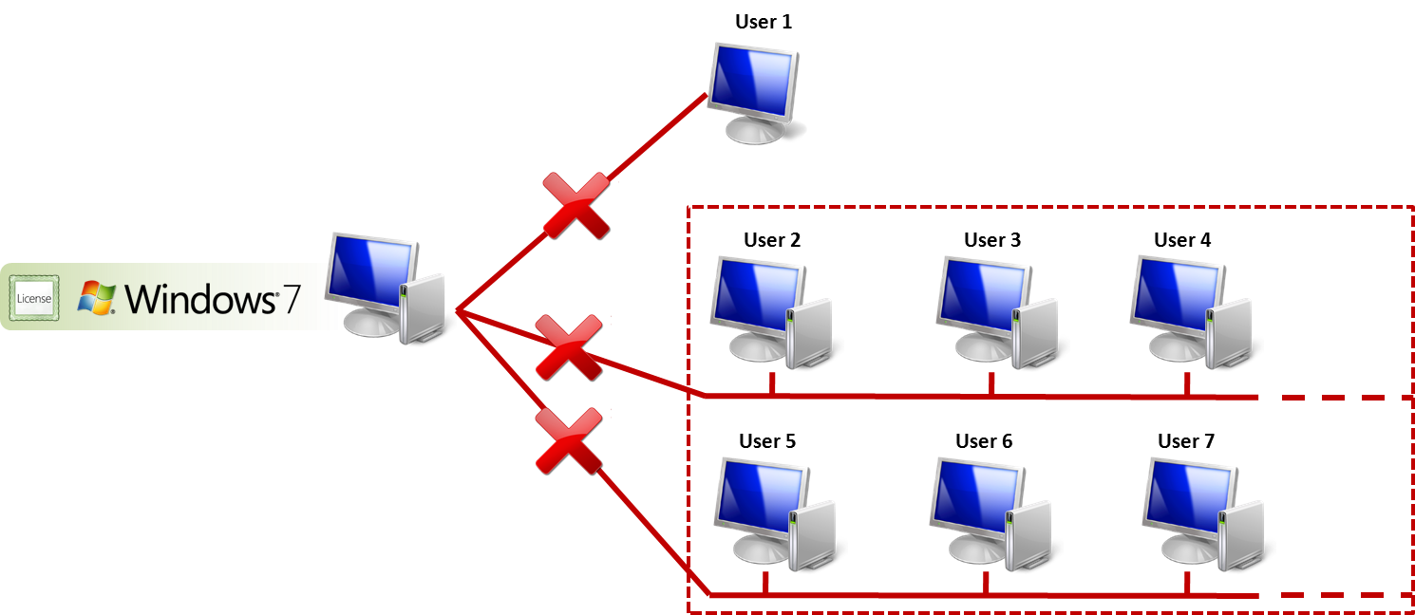

Figure 1: Multiple users simultaneously accessing a single licensed copy of the Windows 7 client.

- No licensing terms exist that allow shared use of the Windows client operating system in the manner illustrated in Figure 1. Under current licensing terms, each host computer or access device using Windows 7, Windows Vista®, or Windows XP must have either a license for such Windows client operating system purchased through the original equipment manufacturer (OEM) channel or the retail/full packaged product (FPP) channel, or a Volume Licensing upgrade purchased on top of a qualifying operating system license.
- The Software License Terms (formerly referred to as the EULA) and Microsoft Product Use Rights (PUR) provide that Windows client operating systems are licensed under the following terms:
  - One license for each device on or from which the client operating system is accessed and used
  - One user accessing the software at a time
  - No use of the client operating system’s runtime and other files to run applications not running on the software

Multiuser Scenarios with Windows Server Operating Systems
While the Windows client operating system does not permit licensing a multiuser solution, the Windows Server operating systems provide a multiuser solution using Remote Desktop Services and/or other technologies.

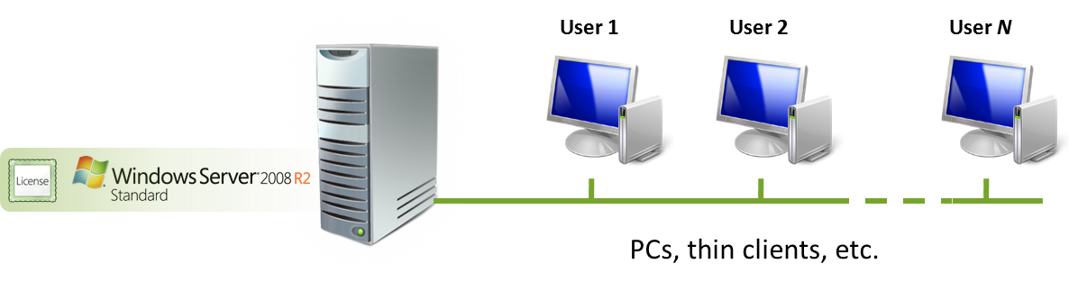
Figure 2: Multiple users can access a licensed instance of Windows Server if every accessing user or device has a Windows Server CAL and Remote Desktop Services CAL.

The Windows Server license terms described in the PUR specify that both a Windows Server Client Access License (CAL) and Remote Desktop Services CAL (RDS CAL) are required whenever a user is remotely connecting to Windows Server to display, access, or use a graphical user interface (for example, a desktop PC or application).

The RDS CAL is required regardless of the technology used to access the server remotely (Microsoft Remote Desktop Services or other third-party software).

Both device and user variants of the RDS CAL are available so that customers can make the best CAL purchase decisions based on their individual needs.
Multiuser Scenarios with Windows MultiPoint Server 2011

Windows MultiPoint Server 2011 is designed specifically for multiuser scenarios. MultiPoint Server comes in Standard Edition and Premium Edition allowing 10 and 20 users respectively to simultaneously share one host computer. Each user has his or her own independent and familiar Windows computing experience at stations directly connected to the host computer.

Users can acquire MultiPoint Server in the following ways:
- Windows MultiPoint Server 2011 Standard: OEM and Open VL channels
- Windows MultiPoint Server 2011 Premium: OEM, Academic VL, and Open VL channels

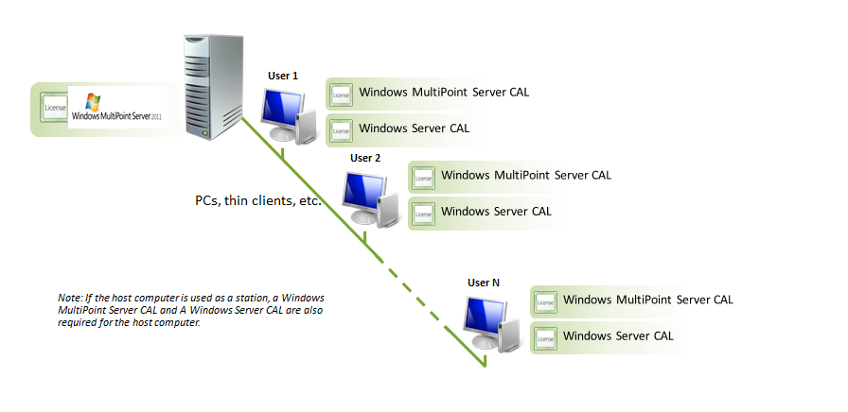

Figure 3: Windows MultiPoint Server 2011 Volume Licensing Model—multiple users can access an instance of Windows MultiPoint Server 2011 if every accessing device or user has a Windows MultiPoint Server CAL and a Windows Server CAL.

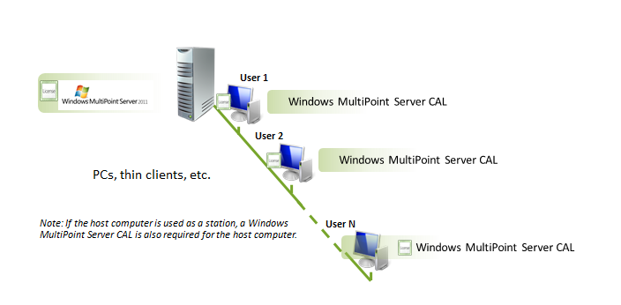

Figure 4: Windows MultiPoint Server 2011 (OEM) Licensing Model—up to 10 users can access an instance of Windows MultiPoint Server Standard 2011 if every accessing device has a Windows MultiPoint Server CAL. Up to 20 devices may access Windows MultiPoint Server Premium with 20 MultiPoint CALs.

The Windows MultiPoint Server 2011 Volume license terms and PUR specify that a Windows Server 2008 CAL and Windows MultiPoint Server 2011 CAL is required whenever a user or device is connecting to a Windows MultiPoint Server 2011 operating system.

The Windows MultiPoint Server 2011 OEM license terms specify that a Windows MultiPoint Server 2011 CAL is required whenever a device is connecting to a Windows MultiPoint Server 2011 operating system.

Both device and user variants of the Windows MultiPoint 2011 Server CAL are available so that customers make the best CAL purchase decisions based on their individual needs.

Campus Agreements and School Agreements
Under the terms of Microsoft Volume Licensing Campus Agreements and School Agreements, licenses that allow a desktop PC device to either run Microsoft products or access Microsoft server resources must be purchased institution wide. (These licenses are known as “Desktop licenses.”) To access the server resources, each desktop PC requires its own CAL. The two agreements differ in their CAL purchase requirements based on how they define “institution wide”:

- Campus Agreement Customers: “Institution wide” for campus customers is the number of all full-time employees (FTE) and staff. “Server Licenses” that allow a server to run Microsoft products can be purchased on an as-required basis for specific servers. However, the number of Desktop Licenses (such as Windows Upgrade or Windows Server CAL and MultiPoint CAL) purchased must match the number of FTE and staff in the institution. This policy applies even when FTEs and staff members use two or more Desktop Licenses in a mutually exclusive manner (for example, using only a Windows MultiPoint terminal and not a standard PC with Windows).
- School Agreement Customers: “Institution wide” for school customers is the number of all “eligible PCs” owned or leased by the institution. Each MultiPoint terminal is considered an “eligible PC,”’ and must be counted. As a result, the number of all Desktop Licenses (such as Windows Upgrade or Windows Server CAL and MultiPoint CAL) purchased must match the number of ALL eligible PCs owned/leased by the school. This policy applies even when the use of two Desktop Licensed products is mutually exclusive or not (for example, if one product used on a MultiPoint Terminal, cannot also be used on a standard PC under the same license or vice versa; both products need to be purchased institution wide.)
Note: An academic institution can use two different products, Windows MultiPoint Server 2011 CAL (WMS CAL) and Windows Client on a mutually exclusive basis. If an academic institution orders both of these products, then both Windows MultiPoint Server 2011 CAL and Windows Client must be purchased on an institution-wide basis. Alternatively, the institution can acquire the Windows MultiPoint Server 2011 CAL under Academic Open, Select License, or Select Plus Agreements for just the number of seats required. This policy applies for both Campus Agreement and School Agreement. (Windows Server CALs for all devices/users are also required but are included with these agreements.)

Microsoft Desktop Application Licensing in a Multiuser Environment:

Enabling Multiuser Scenarios
Microsoft licenses its desktop PC applications on a per-device basis, which means that customers must obtain a license for each desktop PC on or from which the product is used or accessed. When Microsoft desktop PC programs are used in a shared environment, a license must be acquired for every device (desktop PC, thin client, etc.) that remotely accesses the desktop PC program installed on the multiuser system. This license must match the suite/edition, components, language, and the version of the copy of the program being accessed.
For example:
- Product (or suite): Microsoft Office Standard 2007 and Microsoft Office Professional Plus 2007 are different products (or suites). A desktop PC licensed for Office Standard 2007 cannot remotely access and use Office Professional Plus 2007.
- Components: A license for a suite (for example, a Microsoft Office suite) for the accessing device (desktop PC, thin client, etc.) must have exactly the same components as the copy of the Microsoft Office suite being remotely accessed.
- Language: The English/multilanguage version of the Microsoft Office suite cannot be accessed remotely from a desktop PC that is licensed for a single language version of the Microsoft Office suite. Likewise, remote access to a licensed copy of Microsoft Office Multi-Language Pack 2007 requires that the accessing desktop PC be licensed for the Office Multi-Language Pack 2007.
- Version: Microsoft Office System 2003 and the 2007 Microsoft Office system are different versions. You may not remotely access the 2007 Microsoft Office system from a desktop PC that is licensed for Microsoft Office System 2003.
When a Microsoft desktop application is accessed remotely across an organization using Windows Server Remote Desktop Services, a separate desktop application license is required for each desktop PC from which the application is accessed.

Frequently Asked Questions

As a Volume Licensing customer, can I buy new devices that do not have an operating system preinstalled (“naked” PCs)?
Although you can buy devices without an operating system installed, it does not always make the most financial sense. Microsoft Volume Licensing programs only offer upgrade licenses for the Windows client operating system. They do not offer full licenses. Two ways are available for you to acquire full licenses: through an OEM or the retail channel. If you purchase PCs without an operating system, you need to license the Windows operating system through the retail channel. However, the retail price is frequently higher, which means that the best solution is generally to request that your new devices come licensed with a preinstalled OEM version of the Windows client operating system (for example, Windows 7 Professional).

You cannot buy the Microsoft Volume Licensing upgrade license without having a licensed copy of a qualifying desktop PC operating system installed on your device. For more information about which editions of the Windows operating system qualify for upgrades under Volume Licensing agreements visit: http://www.microsoft.com/licensing/windows.

The Microsoft Volume Licensing PUR document says I can use desktop application software on a network device. What does this mean?
Under the network use provision, you can run this desktop application software on a network server and then access and use the software from your licensed desktop PCs using Remote Desktop Services (or similar functionality).

How can I provide my users with a multiuser system?

Users can acquire MultiPoint Server in two ways:
- Windows MultiPoint Server 2011 Standard: From the Open Volume Licensing channel and preinstalled with a computer form OEMs.
- Windows MultiPoint Server 2011: Premium: From the Academic and Open VL channels and preinstalled with a computer from OEMs

As a Campus Agreement or School Agreement customer, I already have Windows Server CALs. Now I want to use Windows MultiPoint Server 2011. Do I need to repurchase Windows Server CALs for this product?
No. Volume Licensing Academic customers who have already licensed Windows Server 2008 CALs only need to purchase the Windows MultiPoint Server 2011 Academic license and Windows MultiPoint Server 2011 CALs. Customers can use their existing Windows Server CALs to meet the Windows CAL requirements of Windows MultiPoint Server 2011.

For More Information
Additional information is available from the following sites:

Enabling Multiuser Scenarios—Presentation Virtualization Using Remote Desktop Services: http://www.microsoft.com/windowsserver2008/en/us/rds-product-home.aspx

Licensing of Microsoft Desktop Application Software for Use with Windows Server Remote Desktop Services: http://www.microsoft.com/licensing/resources/volbrief.mspx

Operating System License Requirements—Initial Operating System and Transfer of License:
http://www.microsoft.com/licensing/resources/volbrief.mspx

2007 Microsoft Office System Components/Migrations/Step-Up License/Multilanguage/OEM Enrollment: http://www.microsoft.com/licensing/resources/volbrief.mspx

Microsoft Product Use Rights: http://www.microsoftvolumelicensing.com/userights/PUR.aspx

© 2011 Microsoft Corporation. All rights reserved.

This document is for informational purposes only. MICROSOFT MAKES NO WARRANTIES, EXPRESS OR IMPLIED, IN THIS DOCUMENT. This information is provided to help guide your authorized use of products you license; it is not your agreement. Your use of products licensed under your volume license agreement is governed by the terms and conditions of that agreement. In the case of any conflict between this information and your agreement, the terms and conditions of your agreement control. Prices for licenses acquired through Microsoft resellers are determined by the reseller.

